|  |  |  |  |  |  |
| --- | --- | --- | --- | --- | --- |
| Date | 12-Dec-22 | | | Tester Name | Mayuri Patel |
| Environment | Penfax - Test | | | Login used |  |
| Operating System | Select OS | Version: | Update: | | |
| Software Used | Select Software | Version: | Update: | | |
| Select Software | Version: | Update: | | |
| Release version | 22.4.1 | | | | |
| Title |  | | | | |
| Test Type | Regression | | | | |
| Test Scenario | Process PEPP Interfund Transfers Report | | | | |
|  |  | | | | |
| Expected Results |  | | | | |
| Pass/Fail | Pass | | | JIRA# | N/A |

Describe your steps with screenshots:

Add Batch process PEPP Interfund transfers Report and Save for run

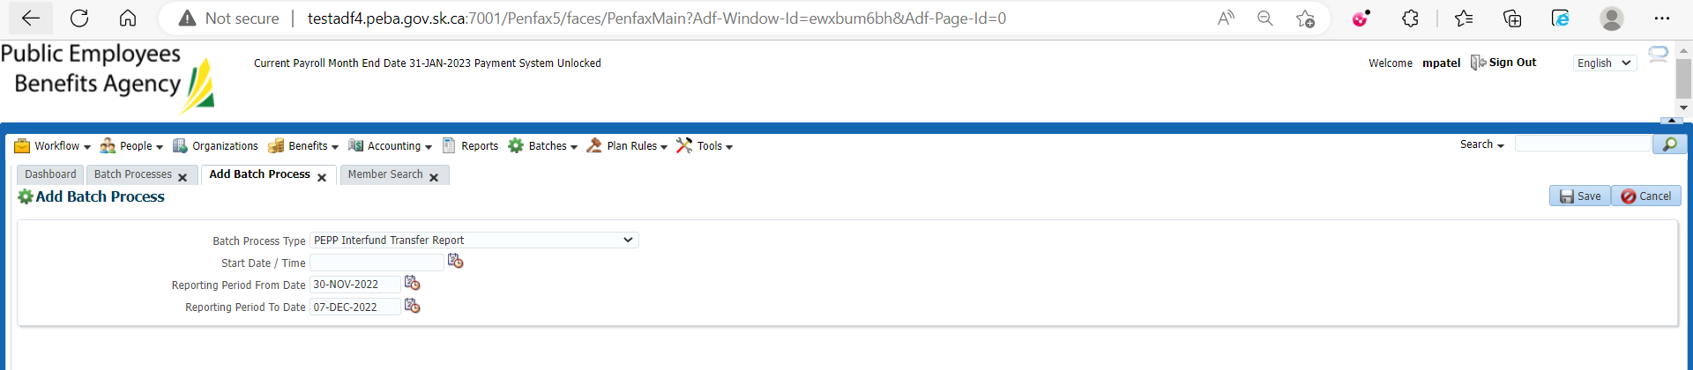

Batch Process is running

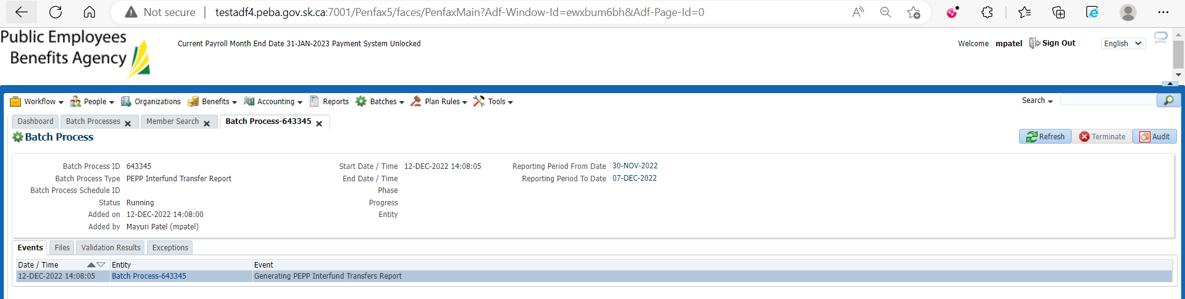

Batch process Succeeded

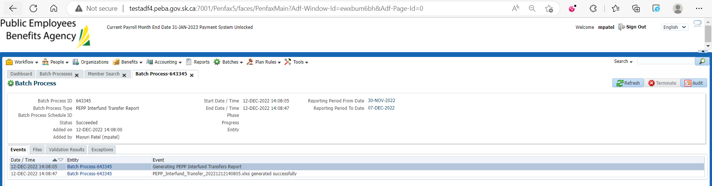

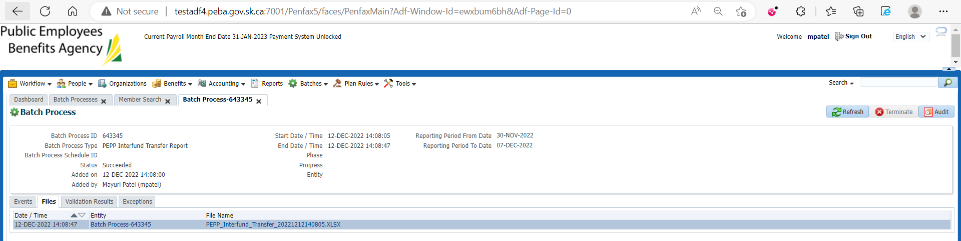

Download and open PEPP Interfund Transfers Report

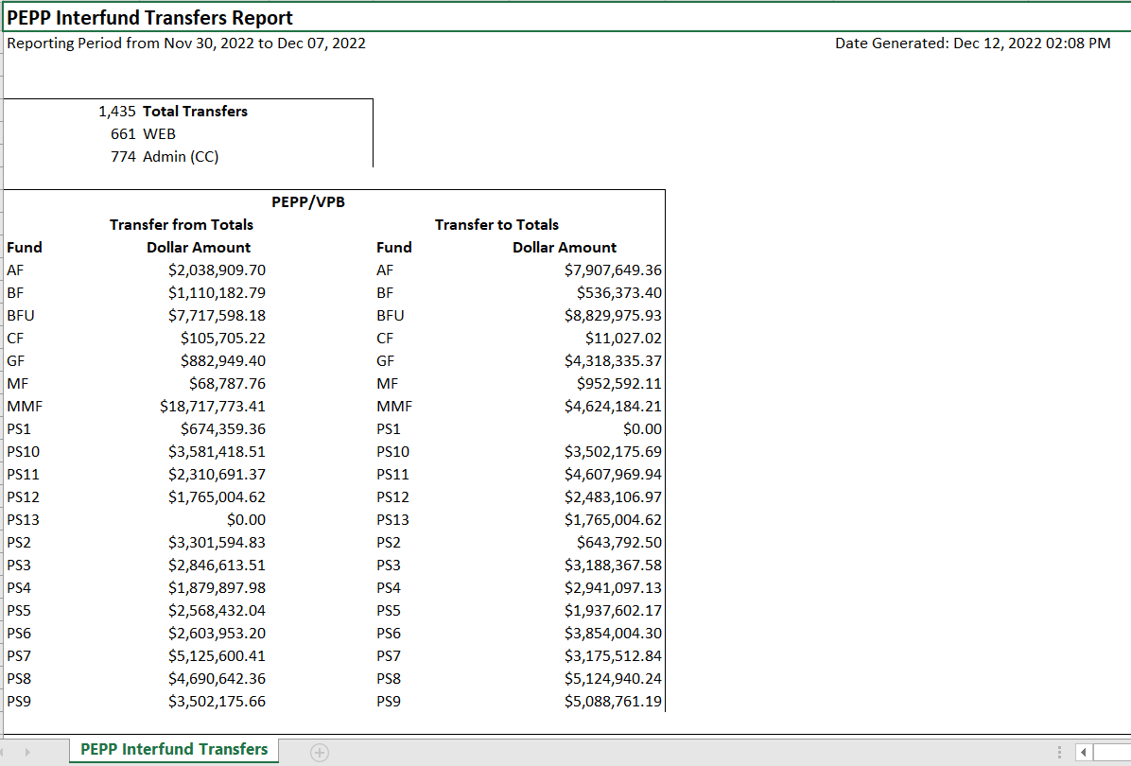

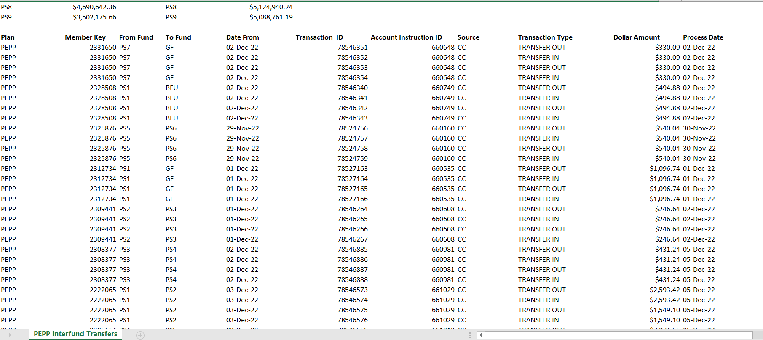

Choose any member from downloaded report file and make sure the said amount is transferred by opening that member in pen fax and looking into the Account Activity

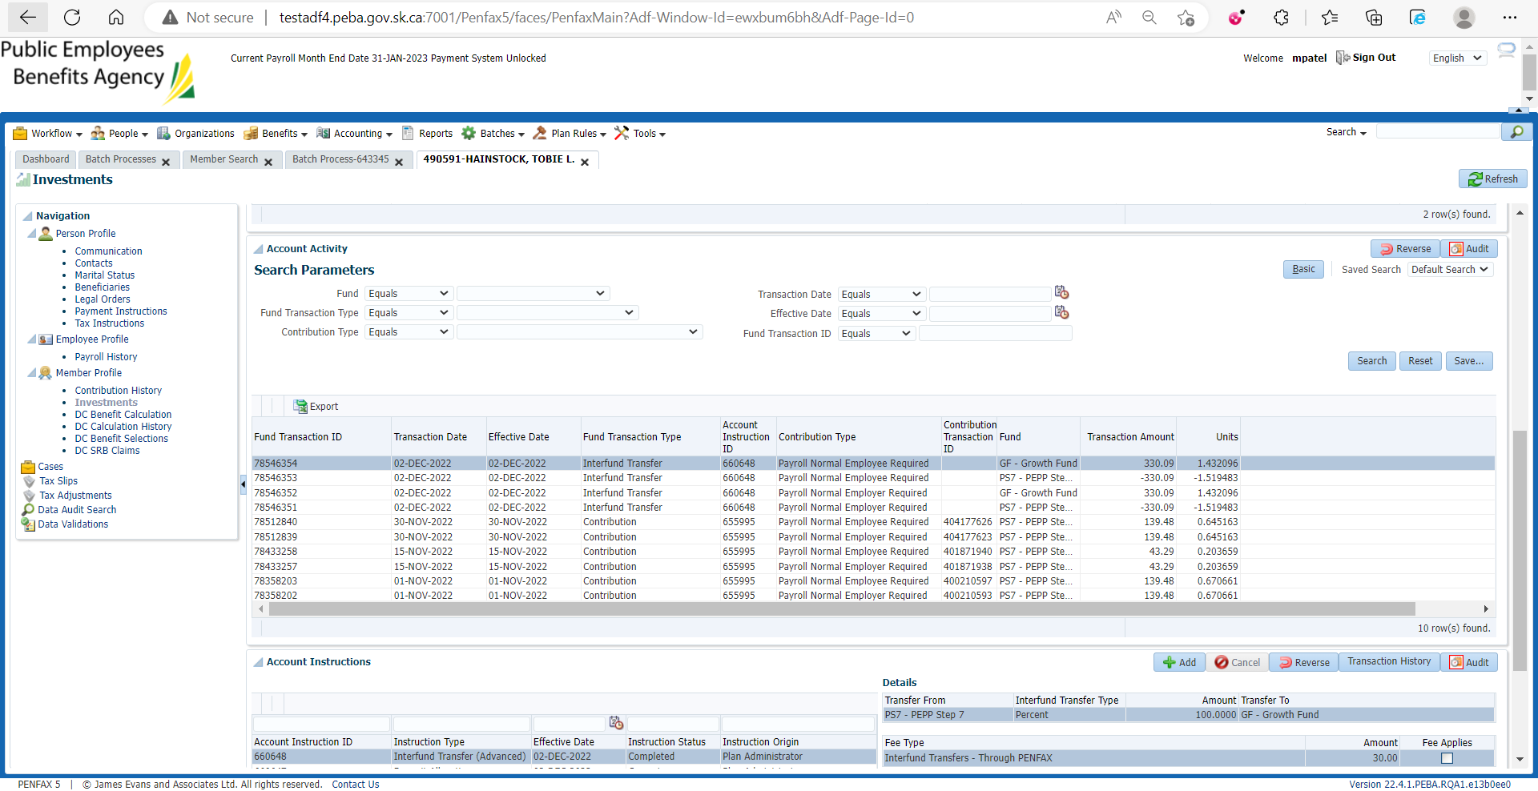

Likewise do the same process for other members in report

PEPP Interfund Transfers Report is saved at: H:\Quality Assurance\Prod Apps\Testing Management\Regression Testing\Nov 2022 - PENFAX 22.4.1 Release\PEPP\Test Results\E15 Reports